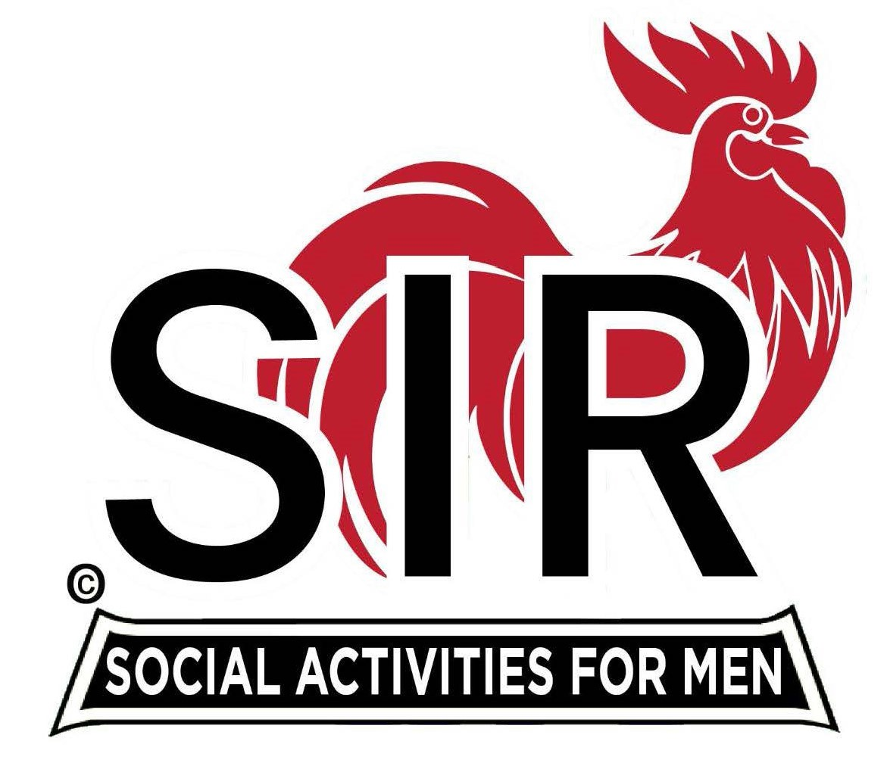
Las Trampas Branch 116
BEC Meeting Agenda
January 19, 2026 - 9:15 AM at Boundary Oak
The Mission of SIR is to enhance the lives of our members through fun activities, events and luncheons while making friends for life.

09:15 | Call to order – Brad Stribling  - Secretary – Tim Tinnes  - Confirm quorum  - Approval of December 29, 2025 Special BEC Meeting Minutes
09:20 | Standing Reports  - Treasurer Report – Charlie Guthrie  - Treasury Report  - Luncheon Count – Eric Linak  - Big SIR Report – Brad Stribling  - D&O Installation  - Goals and action items  - Reference vote on Activities  - New Members this Month:  - Many this month – see Luncheon Agenda  - Membership – Phil Goff  - RAMP Department Head Reports  - Recruitment – Jeff Johnson  - Activity Coordinator – TBD – need a nominee  - Member Relations – Sam Beret  - Publicity – Al Farbman
9:50 | Little SIR Updates – Dan Lawrence  - Speaker Info – Today’s speaker – Eric McNamara  - will be introduced at Luncheon by Paul Freitas  - Birthday Boys – December & January
9:55 | Updates & New Business  - Guests:  - Many this month – see Luncheon Agenda  - Discussion about Luncheon seating  - Holiday Party 2026
10:15 | Adjourn: – Next meeting, February 16th, 2026

